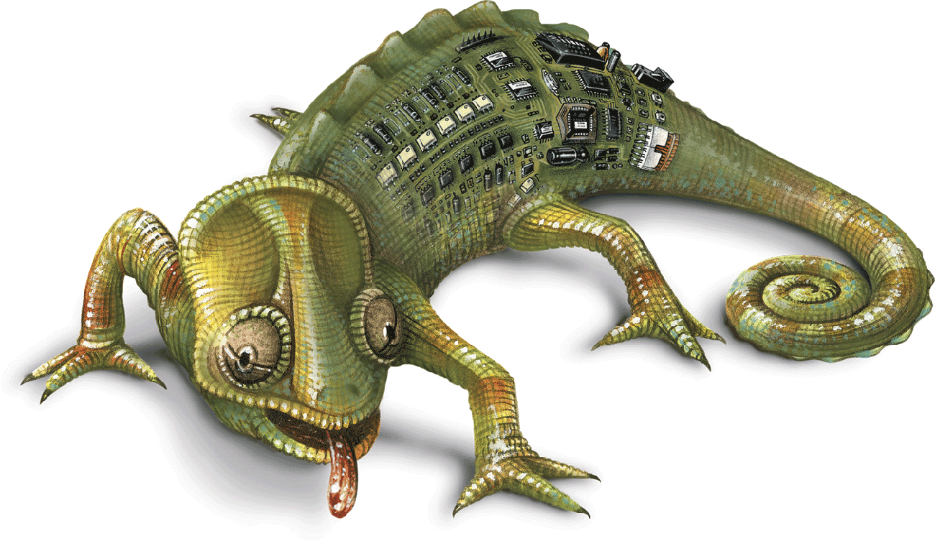
`


TECHNICAL SPECIFICATION form

lighting control
controller KC401 - KC411

STANDARD SPECIFICATION –
Kameleon K4 series

STANDARD LIGHTING CONTROL SYSTEMS

PART 1 - GENERAL

1.01 DESCRIPTION OF WORK

A. This section includes furnishing, installing, and programming of the interior and exterior lighting Automation system proposed for this project. The lighting control system shall be capable of controlling the lighting building equipments from various devices showing on the construction drawing as :
- Lightings equipments
- Lights and motions sensors
- Control switches
- Etc…

- The intent of this specification is to provide complete and functioning lighting control systems and requires that all equipment, fittings, and peripheral devices for correct system operation be quoted and supplied.

- The contractor shall provide all necessary wiring, enclosures types, control modules, power supplies, control stations, central control unit (CCU) as needed to ensure a complete and properly functioning system as indicated on the drawings and specified in this document. The contractor and/or low voltage contractor shall install the system in accordance with the manufacturer’s instructions and recommendations and drawings.

- The electrical contractor shall complete all line voltage wiring, low voltage wiring, and installation of control stations, receptacles, and fixtures indicated on the drawings and defined as part of the Lighting Control System project.
- The contractor shall program the lighting Control system and troubleshoot the control system after the program is installed in the system in accordance with the manufacturer’s instructions and recommendations.
- Related Sections. Refer to Division 16, Section "Electrical Work"

PART 2 - PRODUCTS

2.01 LIGHTING CONTROL SYSTEMS, GENERAL

Automation, Lighting Control Systems.
The equipment covered under this portion, the specification shall consist of a sequencer, timeclock, occupency sensor and daylighting automation system for the automatic switching of lighting as indicated on drawings and described herein shall included.

The system is to be capable of incorporating a wide range of controls from multiple controls pattern including those shown in the list below. These should include but not be limited to wall mount controls, BAS control, occupancy sensors and light level sensors.
Relays Panel (as described on drawing)
Group Controllers
Schedulers
Sequencers
Occupancy Sensor Interfaces
Light Sensor Interfaces
Remote Controllers
Programable time clock

2.02 Sequencer module Model KC-401

The automation panel shall provide a control module (sequencer) is fully configurable by itself; without an entry keyboard or external computer. Configuration (relay group assignment) is done through a tactile feedback membrane switch. Furthermore, a beeper is activated every time a button is properly pushed as on the KC-401 model.

Hereunder are the main characteristics of the sequencer:
- Din rail mounted
- 24 volts ac supply
- Operates up to 16 relays 2 wires per sequencer.
- Operates up to 32 relays with easy communication add-on.
- Up to 4 relay groups can be assigned. One relay can be part of more than one group.
- 4 entries for an individual group operation. Different switches can be linked to these entries: dry contact or polarized momentarily.
- Flick warning available for closing time.
- Time On Extension (2 hours) for lighting during off-hours.
- On operation only
- Off operation only
- The sequencer can detect 4 relay state: unplugged, open , close and short circuit. Display is LED.

2.03 Time Clock Model KC-411.
The KC 411 is an astronomical type clock, which means it can calculate: the sunrise and sunset hours. This calculation will take into consideration the location where the clock is installed (latitude and longitude). Also, the KC411 has the following characteristics:
- Astronomical type clock;
- Calculations of the sunrise and sunset hours every day;
- Daylight savings;
- 4 clock types (once, daily, weekly and monthly);
- 4 priority levels;
- 8 relays output or channels output for other KC 401;
- 2 universal group entries (zones);
Group options:
- On only;
- Off only;
- Warning at shut down;
- 2 hours Fix extension after shut down.
- 2 universal photocell entries:
- Photoconductive type (2 wires) ;
- Photodiode type (3 wires).

  - RELAY PANELS
- Where indicated on the drawings, provide a factory pre-assembled relay panel. The panel’s enclosure shall be for surface or flush installation, with a screw-on cover or hinged door assembly as required.
- The panel shall consist of a pre-assembled interior insert; UL/CSA approved with apacities for 8, 16, 32, 48 and 64 relays as required. Panel enclosure must be as show to the drawing type 1, 12, 3R or 4X with UL/CSA Approved.
- Panel interior shall have the following pre-assembled and pre-wired:
  - Suitable divider separating class1 and class 2 compartments
  - Control transformer, UL/CSA approved for class 2 circuits
  - Low voltage relays as required by switched circuits shown on plans or schedules
  - Control devices as required
- Control cabinet are to be fitted with removable dividers and metal cable grommets to allow connecting high voltage feeder-line from the top and/or the sides of the boxes. Similarly, low voltage feeder-lines are to be connected from the bottom and/or the sides of the boxes. Control boxes are made of at least gage 14 cold rolled steel not exceeding 4 inches (101 mm). Flush or surface mount is available.

2.05 RELAYS
    - Lighting control relays shall be mechanically latching and shall come complete with a manual ON/OFF switch. The mechanical switch shall continuously display the true state of the relay’s internal contacts. Relays requiring control power for manual operation and/or status feedback are not acceptable.
    - Single pole relays shall be rated and UL-CSA listed for 120, 277 or 347 VAC lighting loads at 20 amps.
    - Double pole relays shall be rated and UL-CSA listed for 208, 240 or 480 VAC lighting loads at 20 amps.
    - Each lighting control relay shall be contained in an individual molded casing and shall be capable of containing a short circuit fault current of 14,000 amperes. Relays with exposed electronic devices are not acceptable
    - Each lighting control relay shall be capable of controlling incandescent, fluorescent, electronic ballast and HID lighting loads.
    - Lighting control relays shall include captive, color-coded screw terminals for both the line voltage and the low voltage connections.
  - LOW VOLTAGE WALL SWITCHES
Local switches are to be low voltage, momentary action, and two-way single-pole type. They will have indicator lamps as requested.
- Low voltage control switches and switch hardware shall mount to standard wall boxes.
- Switch modules shall be available with 1, 2 and 3 switches per gang and shall fit into standard ‘Decora’ style switch plates.
- Individual switches shall include an integral tri-state LED to indicate both ON and OFF states (red=ON, green=OFF).

- Each switch shall be clearly identified with a paper switch label. The label shall be held in place with a clear plastic cap and shall be field replaceable should the operation of the switch change. Permanently etched switches are not acceptable.
- Switches shall have color coded captive screw terminals. Use #18 AWG solid conductors.
- Where required provide keyed switches to control lights. Switches shall include an integral tri-state LED to indicate both ON and OFF states (red=ON, green=OFF).

2.07 OCCUPANCY SENSORS
Where required, provide a PIR occupancy sensor seilling or wall mount type as show to the drawing. The occupancy sensor shall control up to 4 relays directly. It shall also be possible to connect wall switches in parallel to each relay for occupant override if required
Occupancy sensor to include the following features:
        - Adjustable time out (30 sec to 30 min) and sensitivity
        - Tilt & swivel lens direction adjustment
        - Coverage of 1600 sq. ft., Indoor ceiling mount, ceiling heights 8’ to 16’ max
        - Function select – on/off switching or off-only switching

2.08 EXTERIOR PHOTOMETRIC SENSORS
- Provide where required an exterior photometric sensor capable of sensing from 1-60,000 lux. The sensor shall be connected to the lighting control network via a 4-wire (2 power + 2 data) dataline.
- The ambient light level shall be continuously monitored and be displayed by the Network Manager.
- One exterior sensor shall be capable of controlling one, some or all relays in the entire lighting control network shall permit different relays to switch at different light levels. Lights shall be controlled by ‘sensor only’ or by a combination of time& light level.

2.09 INTERIOR PHOTOMETRIC SENSORS
  - Provide where required an interior photometric sensor capable of sensing from 1-60,000 lux. The sensor shall be connected to the lighting control network via a 4-wire (2 power + 2 data) dataline.
  - The ambient light level shall be continuously monitored and be displayed by the Network Manager
  - Each interior sensor shall be capable of controlling one, some or all relays in the entire lighting control network and shall permit different relays to switch at different light levels. Lights shall be controlled by ‘sensor only’ or by a combination of time & light level

PART 3 - EXECUTION

3.01 INSTALLATION

A. The system shall be installed in a craftsman-like manner and in compliance with all applicable local and national codes. Equipment shall be installed in a conditioned space where temperature/humidity does not exceed 90 Degrees F/40% R.H. Installed system shall not be exposed to visible airborne dust and dirt. All wiring in cabinets and control cabinets shall be in a neat manner with all conductors labeled and neatly harnessed with wire ties. All equipment shall be protected from dust, paint, and construction debris.

B. Prior to receiving power from the cabinet, each branch circuit shall be tested for shorts and any shorts corrected. Prior to inspection by the engineer and technician, all equipment shall be cleaned with all dust, metal cuttings, wire clippings, spilled or over-sprayed paint, and miscellaneous debris.

3.02 COMMISSIONING

The manufacturer shall provide a factory trained technician to inspect the system for proper installation, test it for proper operation, and program the system as directed by the Engineer. Any wiring or installation errors noted by the factory technician shall be corrected by the contractor at no charge to the owner.

3.03 REFERENCES

A. Comply with the applicable standards and codes.

- National Fire Protection Association (NFPA) NFPA 70
- National Electrical Code and Canadian Electrical code
- Underwriters Laboratories, Inc. (UL) and Canadian Standard
- UL 508A Industrial Control Panels

4.01 SUBMITTALS

Product Data. Provide detailed drawings, including wiring diagrams, of all panels, equipment, and assemblies. Provide complete hookup information and maintenance data for inclusion in Operating and Maintenance Manual.

5.01 QUALITY ASSURANCE

Manufacturer's Qualifications.
Manufacturer shall have been regularly engaged in the manufacturer of lighting automation equipment for a period of at least ten years.
Manufacturer shall have been ISO9001-2000 certificate.

Listing and Labeling. All control and dimmer cabinets shall be listed and labeled by UL CSA.

Commissioning and Programming. Manufacturer shall provide a complete checkout of system installation prior to the energizing of equipment. On this same trip, manufacturer shall provide the designated owner's representative with a minimum of five hours training in the operation and maintenance of the system. Contractor shall provide manufacturer and owner at least fourteen days notice to schedule check-out and demonstration.

6.01 WARRANTY

Submit manufacturer's warranty that equipment shall be guaranteed for 18 months from shipping date or 12 months from the commissioning date.

7.01 EQUIVALENCES

Engineering may ask for proof of equivalence to be supplied by the contractor through documents such as technical specifications or reports issued by recognized laboratories that have conducted tests on the proposed goods, equipment and/or components.

8.01 TECHNICAL SUPPORTS AND SERVICE

The contractor shall supply material and services necessary for the installation of a complete lighting management and control system according to plans and specifications here above described.

END OF SECTION

Load Schedule – Table

LIGHTING CONTROL PANEL – CONFIGURATION – CONTROL PROFIL
Breaker # | Relay # | Description - Location | Switches | Sequencer | Sensor | Time Clock
 | 1
 | 2
 | 3
 | 4
 | 5
 | 6
 | 7
 | 8
 | 9
 | 10
 | 11
 | 12
 | 13
 | 14
 | 15
 | 16
 | 32
 | 33
 | 34
 | 35
 | 61
 | 61
 | 62
 | 63
 | 64

Control Sequence and details:
Legend..
- BAS Building Automation system
- DLS Dailight sensor
- TC Time clock
- OP Outdoor Photocell
- …
- …

